ASSISTED CODING
END TERM EXAM
NAME:H.V.S.VYSHNAVI
H.NO:2403A51182
BATCH-06
SET -08
Q1)
TASK-1:
PROMPT:
“Generate a Python class structure for implementing a singly linked list to store and manage student records.”
CODE:
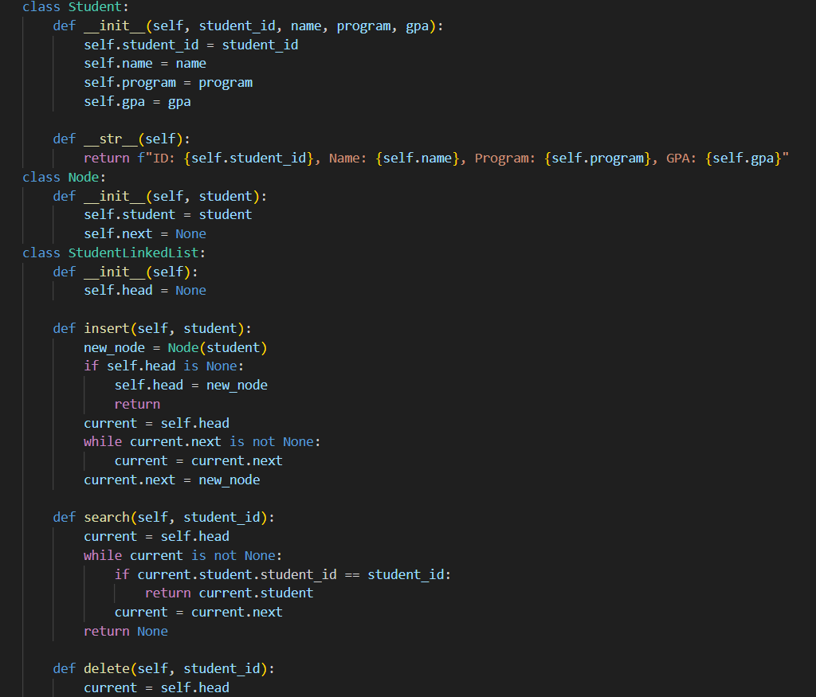
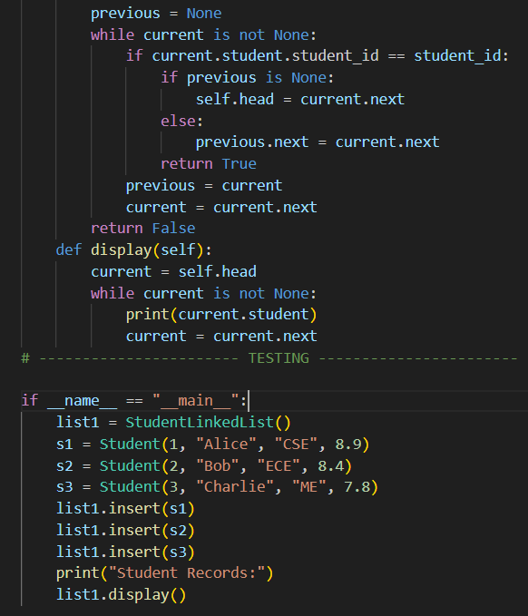
OUTPUT:
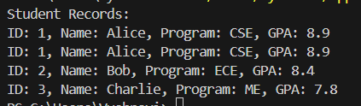
OBSERVATION:
“The experiment demonstrates how a singly linked list stores and manages student records dynamically. The operations such as insertion, deletion, search, and display are implemented successfully. The linked list allows efficient memory usage and flexible manipulation of data without needing contiguous memory.”

TASK-2:
PROMPT:
“Generate Python code for a linked list with AI-suggested methods: insert, delete, and search.”
CODE:
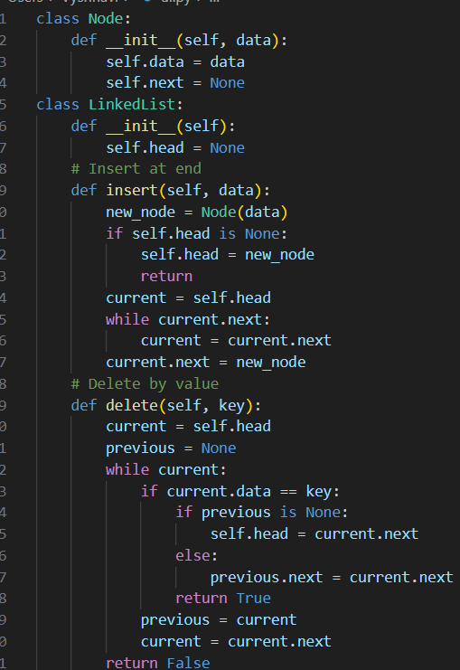
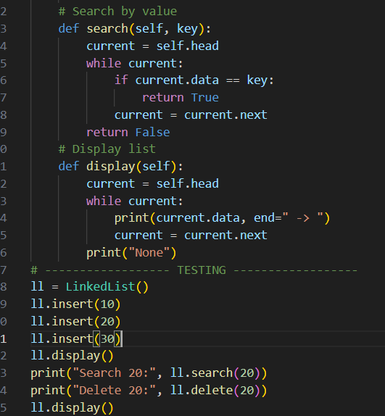
OUTPUT:
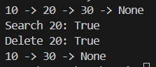
OBSERVATION:
“Insert, delete, and search operations were successfully added to the linked list. The list can dynamically add items, remove specific items, and check for the presence of a value. This shows how linked lists manage data flexibly without using continuous memory.”

Q2)
TASK-1:
PROMPT:
“Generate Python heap logic to create a student priority queue based on GPA.”
CODE:
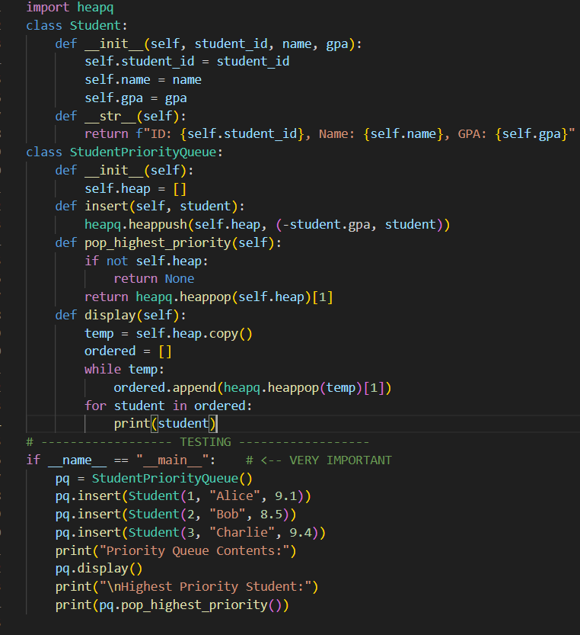

OUTPUT:
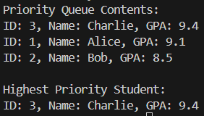
OBSERVATION:
“The heap-based priority queue successfully organizes students according to GPA, giving higher priority to students with higher scores. The heap structure allows fast insertion and retrieval, demonstrating efficient priority management using AI-generated heap logic.”
TASK-2:
PROMPT:
“Test the student priority queue by inserting real student data and displaying the highest-priority student using heap logic.”
CODE:
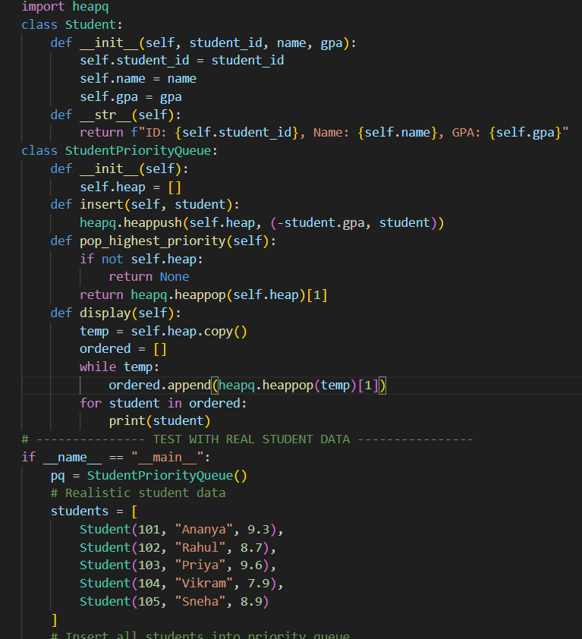
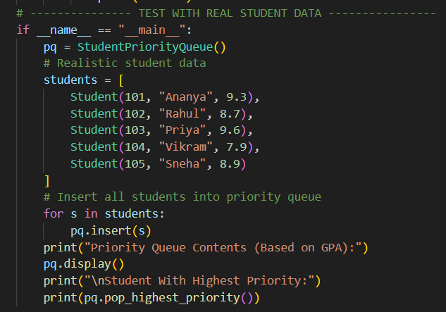
OUTPUT:
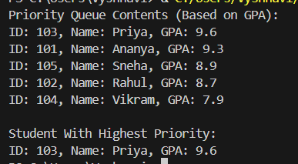
OBSERVATION:
“Real student data was successfully inserted into the priority queue. Students with higher GPA automatically appeared at the top, demonstrating correct heap-based priority handling. The output shows that the system accurately selects the student with the highest priority.”

